Technolord’s MiniMacro

Introduction

MiniMacro is a Windows message queue recorder. In simpler terms, each action in a computer, whether from the mouse or keyboard, is processed through the Windows message queue. MiniMacro simply writes these messages to a file so they can be entered into the queue again later.
There are a lot of professional uses for this software, such as interacting with other software automatically, or launching other programs, applying text to screen fields, pressing buttons or other objects on the screen automatically. You don’t have to be there when this happens if you use scheduling software or TECHNOLORD’s Job Runner, all of these tasks could be performed automatically even while you are home in bed. Businesses can use it for the repetitive tasks of their employees while developers can use it for regression testing.

Interface Design
Here you will learn how to use the MiniMacro program. When designing the program the TECHNOLORD staff felt that it would help their customers tremendously if it resembled the old Windows recorder. MiniMacro has a small function area with 6 buttons and 1 slide bar. It is easy to hide and tucks away into the system tray of the Windows operating system.
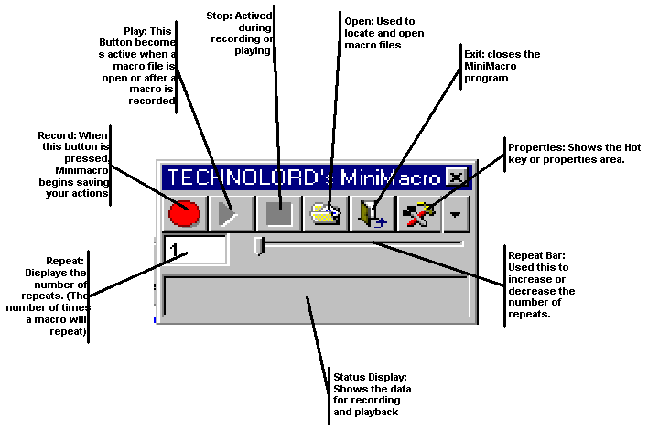

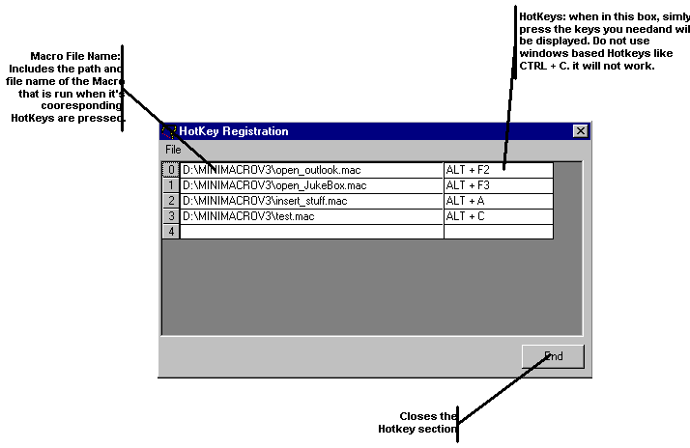

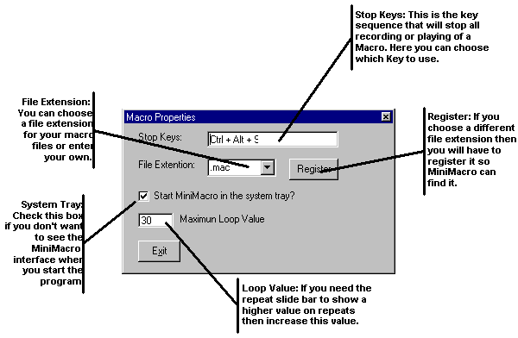

Tips And Tricks
When recording macros, one thing you should keep in mind is that you computer does not always function the same every time. At the time you recorded the macro your computer may only have had one window open and using a small amount of memory, but when you play the macro, you may have 5 windows open and in the middle of an Internet file transfer using the maximum amount of memory. The message queue doesn’t care about that your macro will be pushed through the queue just as it was recorded. So if your computer is running slower because of open tasks you may consider recording a slower macro just so the Window queue doesn’t ignore your actions.

